DAY-02
Date:28/06/2026
Find out equivalence class partitioning which accepts name fields alphabets only
S no | Normal Test Data | Divide values into Equivalence classes | Test Data Using ECP
1 | Vishnu12 | Numbers (Invalid) | Ram123
2 | Vishnu | Alphabets (valid) | Ramu
3 | Vish @ nu | Spaces & special characters (Invalid) | R a m @ k
4 | Empty Input | (Invalid) | ------------

==================================================================================
1)Find out ECP and Boundary value Analysis for Insurance Application which accepts Username 18 characters username, age 18 and 58

SNO | Normal Test Data | Divide values into Equivalence classes | Test Data Using ECP
1 | vishnuvardan | Lessthan 18 characters(Invalid) | ajaykumar
2 | Ramkrishna3456 |  | Bvishnuvardanreddy
3 | Rajashekar | More than 18 characters(Invalid) | veravenkataphanikumar

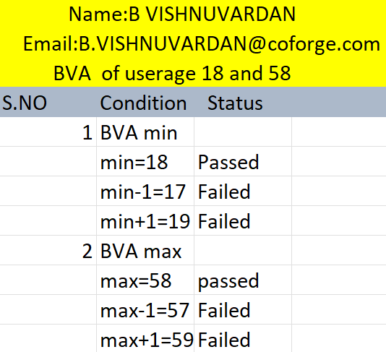

2)Search five images of Decision Table create condition based on corresponding actions
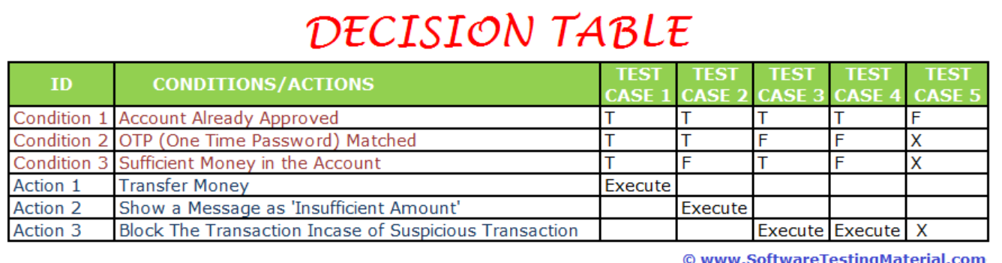
Login to an Web Application
Conditions |  | R1 | R2 | R3 | R4 | R5 | R6 | R7
C1 | Email | Empty | Valid | Invalid | Valid | Empty | Valid | Invalid
C2 | Password | Empty | Invalid | valid | Valid | Valid | Empty | Invalid
Actions | Login | No | No | No | Yes | No | No | No

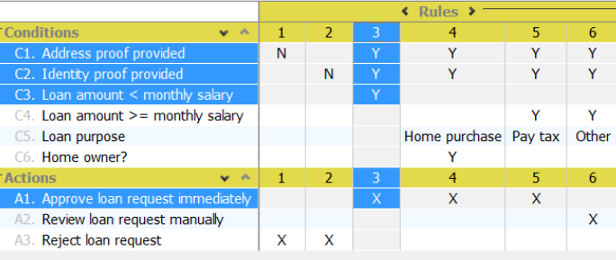

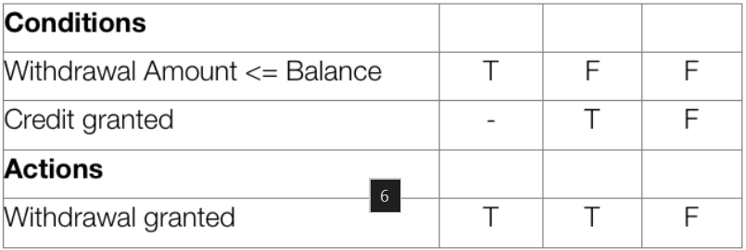

3)State Transition Technique – Find out minimum five images from browser identify state transition techniques.
State Transition Technique : ATM PIN Change
States: Idle, Card Inserted, PIN Verified, PIN Changed
S. No | Current State | Event / Input | Next State | Expected Result
1 | Idle | Insert debit card | Card Inserted | Prompt for PIN
2 | Card Inserted | Enter correct PIN | PIN Verified | Display main menu
3 | Card Inserted | Enter incorrect PIN (3 times) | Idle | Card retained/ejected
4 | PIN Verified | Select Change PIN & enter new PIN | PIN Changed | PIN updated successfully
5 | PIN Changed | Eject card | Idle | Screen resets to default

Online Shopping Checkout
States: Cart Empty, Product Added, Checkout, Payment Successful
S. No | Current State | Event / Input | Next State | Expected Result
1 | Cart Empty | Select product & add to cart | Product Added | Product displayed in cart
2 | Product Added | Click checkout | Checkout | Display address and payment options
3 | Checkout | Enter invalid address | Checkout | Display address validation error
4 | Checkout | Enter valid details & make payment | Payment Successful | Order confirmation displayed
5 | Payment Successful | View order | Payment Successful | Order details displayed

Login Authentication
States: Logged Out, Login Page, Credentials Submitted, Logged In
S. No | Current State | Event / Input | Next State | Expected Result
1 | Logged Out | Open application | Login Page | Login form displayed
2 | Login Page | Enter username and password | Credentials Submitted | Credentials submitted for validation
3 | Credentials Submitted | Enter invalid credentials | Login Page | Error message displayed
4 | Credentials Submitted | Enter valid credentials | Logged In | Dashboard displayed
5 | Logged In | Click Logout | Logged Out | Session ended and login page displayed

Food Delivery Order
States: Browsing, Cart Created, Order Placed, Order Delivered
S. No | Current State | Event / Input | Next State | Expected Result
1 | Browsing | Select restaurant & food item | Cart Created | Selected item added to cart
2 | Cart Created | Click Place Order | Order Placed | Order confirmation displayed
3 | Order Placed | Restaurant accepts order | Order Preparing | Order status shows preparing
4 | Order Preparing | Delivery partner delivers order | Order Delivered | Delivery completed successfully
5 | Order Delivered | Rate the order | Order Delivered | Rating submitted successfully

